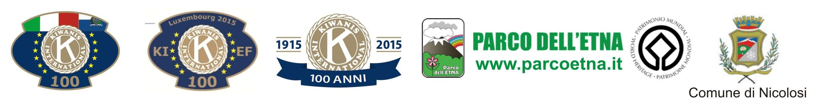
ETNA WORLD HERITAGE
KIWANIS EUROPEAN YOUTH CAMP 2015
ITALY 3/8 August
(for boys and girls aged 16 to 23 years)

- REGISTRATION FORM –
1.1 | First name
1.2 | Surname
1.3 | Gender (M or F)
1.4 | Address
1.5 | Date of Birth
1.6 | Age (in camp)
1.7 | Member of Club (Yes/No) (if Yes, indicate Key Club or Junior Club and club name)
1.8 | Invited to participate by the Kiwanis Club named:
2.1 | Mobile Phone (inlc. prefix)
2.2 | E-mail
2.3 | T-shirt Size (S, M, L, XL, XXL)
2.4 | Photo/Video authorization**
2.5 | Swimmer? (Yes/No)
3.1 | Allergies?* (Yes/No)
3.2 | Vegeterian?* (Yes/No)
3.3 | Medical treatment* (Yes/No)
3.4 | Other
4.1 | Date, place of signature(s)
4.2 | Signature of participant  (scan and insert)
4.3 | Parent's signature (only if participant is under 18 y.o.)
4.4 | Parent/Contact person's phone number and e-mail
* If yes, specify please
** By signing this registration form there is provided permission to use all pictures and videos, etc. taken during the event by Kiwanis International
! Signed registration form shall be mailed to country group leader. Registration is completed by paying the participation fee.
! Each participant is selfresponsible for valid accident and health insurance to participate the event.

Send this registration form to: rosarioprevitera@kiwanis.it and kiwanisitalia@kiwanis.it
After acceptance, will be notified Regulation of CAMP and IBAN for payment of the participation fee (100,00 euro).

